GRADE 8
GEOGRAPHY
CHAPTER 2
NATURAL RESOURCES - LAND,, SOIL AND WATER

https://youtu.be/562mI0WnKX0

LAND RESOURCES
- Land is the most important gift of nature.

- 29% of the earth's surface is covered with land.

- Humans meet most of their needs from it .

- All parts of the land are not useful nor habitable.

- Uneven population distribution.

- Only 30% of the world's land area is occupied by 90% of the world's population.

- Generally uninhabited or sparsely populated areas are also there,
- such as steep slope areas, marsh lands, deserts- like extreme hot or cold climate areas, and thick forests.=
STEEP SLOPES
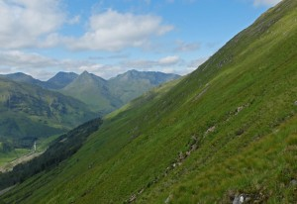

MARSHLANDS
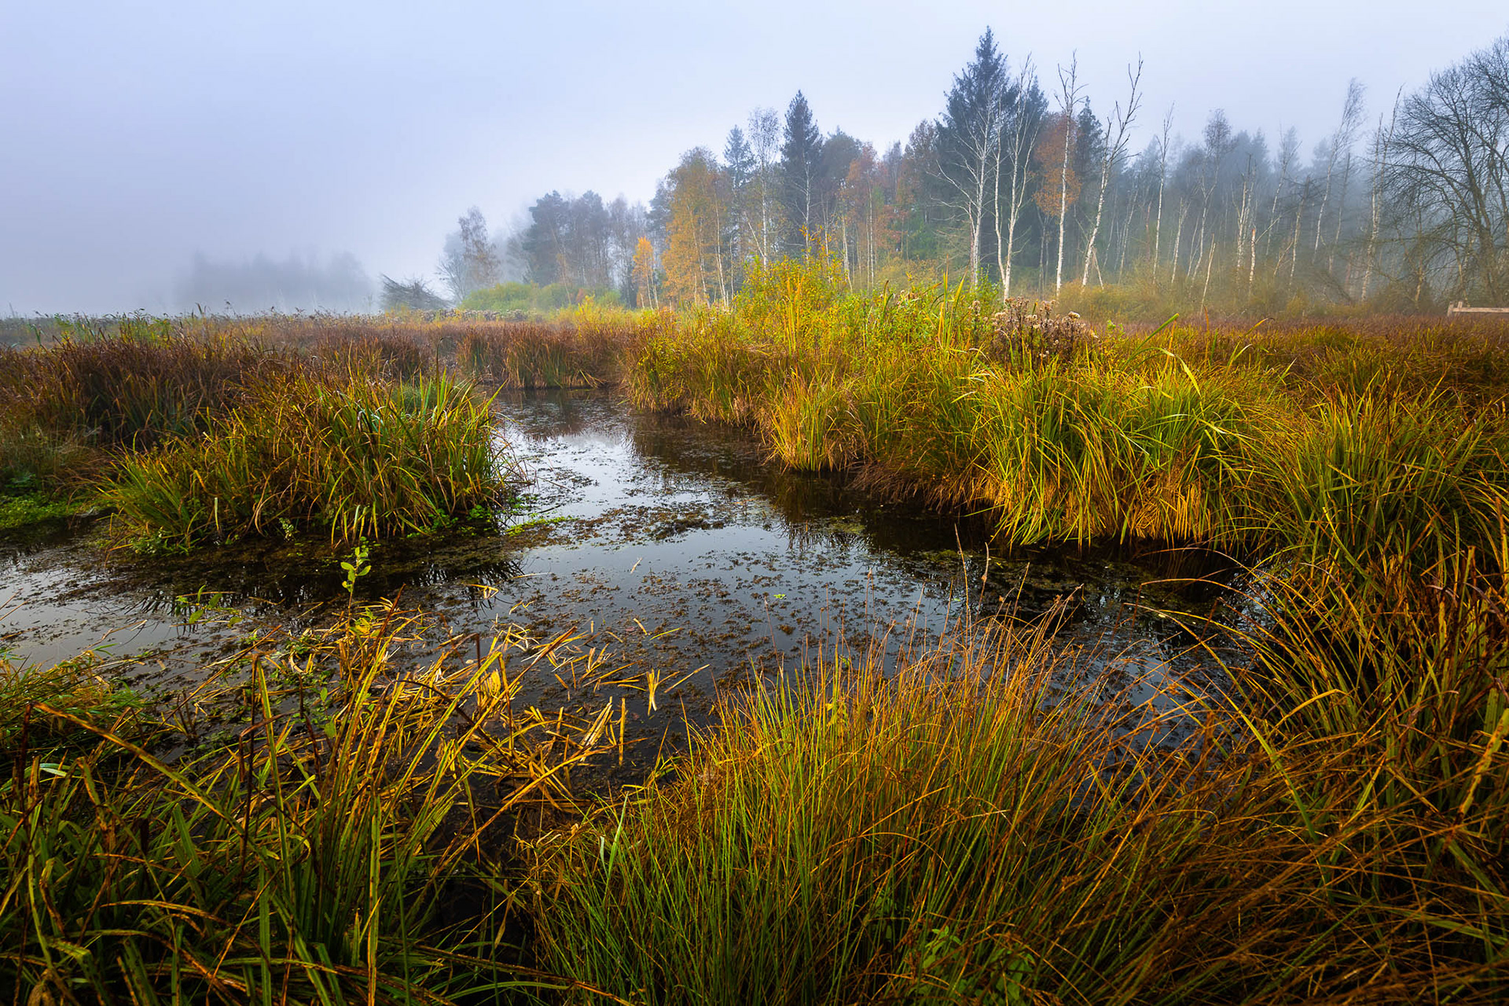

DESERTS EXTREME HOT
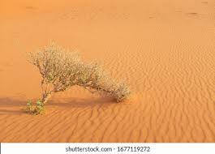

DESERTS EXTREME COLD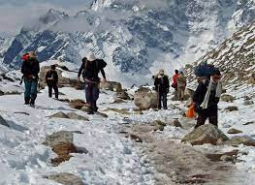

DENSE FOREST
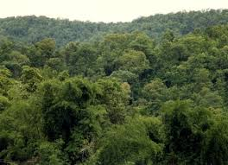

Plains and river valleys
- The plains and valleys have suitable climatic conditions.

- It offers favourable factors for farming, so these regions are densely population.
River valleys
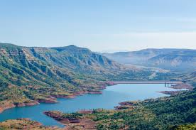

Plains

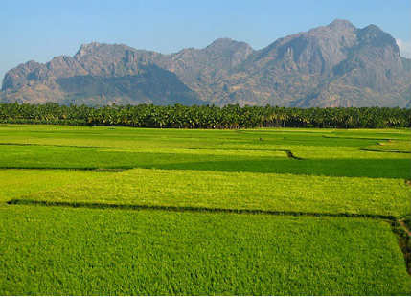

LAND USE
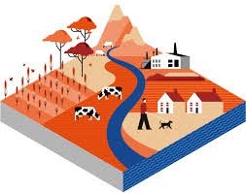
We use land for different purposes such as
Cultivation
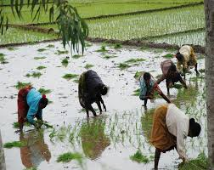

Grazing
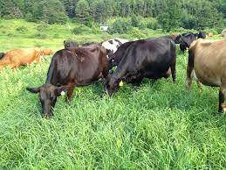

MINING
COAL
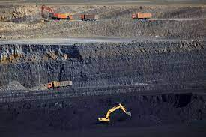

GOLD
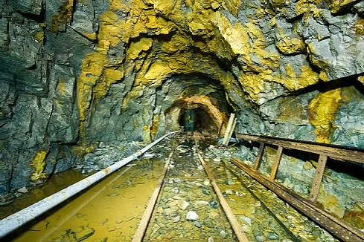

INDUSTRIES
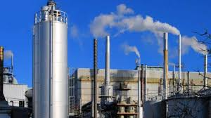

SETTLEMENTS
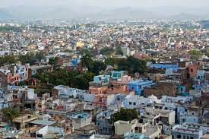
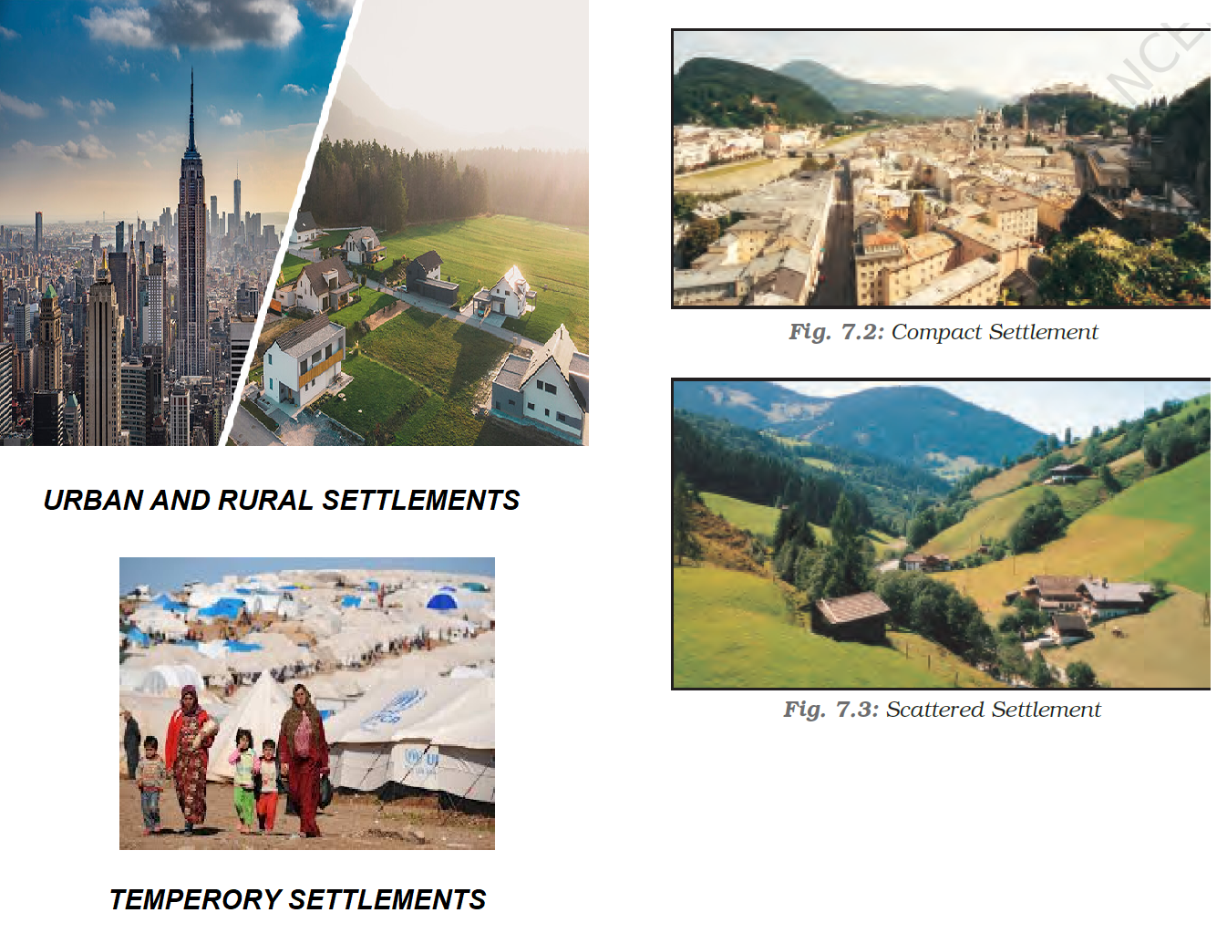

- This land utilization is called land use.

- This land use depends upon various factors like Physical, economic and human
- Some of these factors are
relief
Climate
Soil
land tenure
technical knowledge of the people
Duration of any particular occupations

- Certain physical factors limit the land use; they are relief,climate and soil.
- The amount of land used for a particular purpose varies from place to place,time to time even in the same region.

- The usage of land in a particular area is deciding by certain factors like
- Climate
- Relief
- Quality and thickness of soil
- The nature of rocks and minerals
- The availability of water

Factors affect the land use
- The lifestyle of the people.
- The location of a place and its accessibility .
- We modified the land
eg.Prairies

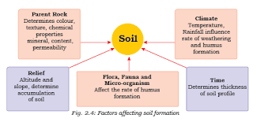

SOIL

The upper most layer of the land’s surface which has minerals is called soil. Soil is formed due to the process of weathering.

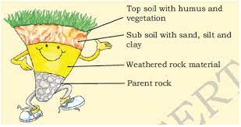

Factors of soil formation
The formation of soil is a very slow process.
It depends on the nature of parent rock, climate, relief features, flora, fauna, microorganisms and time.
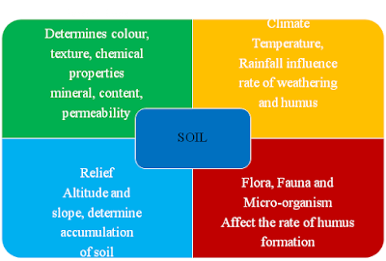

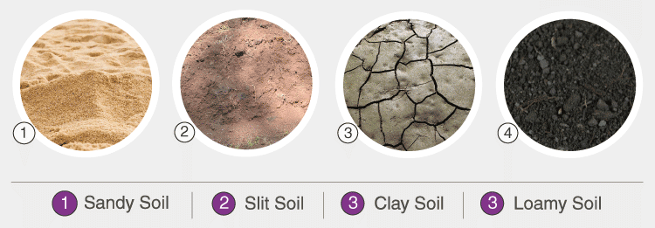

SOIL EROSION
The removal of topsoil is known as soil erosion.
Soil loses its fertility.
Physical factors and Cultural factors cause soil erosion .

Physical factors
Slope of the land, intensity of rainfall, and velocity of wind .
Cultural factors
deforestation, overgrazing, overuse of chemical fertilisers and pesticides, erosion, landslides and floods , over utilisation and unscientific farming methods.

Deforestation Overgrazing

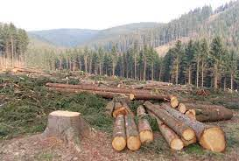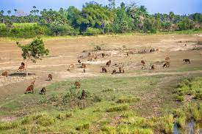

Chemical Fertilisers

Pesticides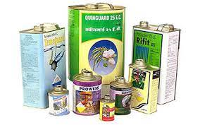

Erosion

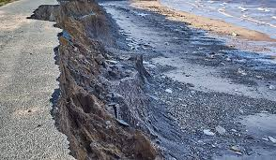

Landslides
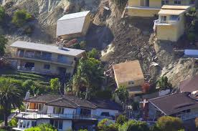

Floods
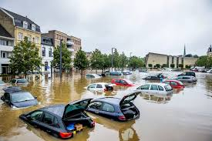

SOIL CONSERVATION
Steps taken up to save the soil from its degradation is called soil conservation. These are the methods that can be used for soil conservation.

Mulching
The process of covering the bare ground between plants with a layer of organic matter like straw is called mulching.
This helps in retaining soil moisture.
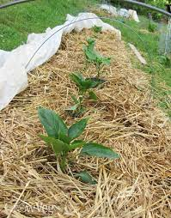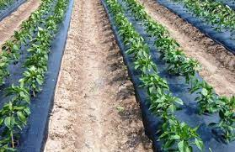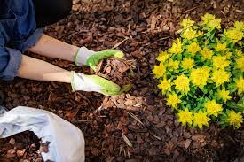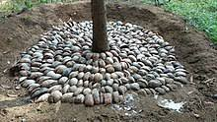
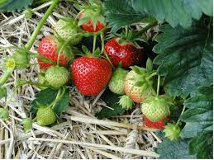

Afforestation
Rows of trees should be planted.
Overgrazing
Animals must be checked.
Fodder should be raised as a crop.

The existing agricultural practices should be changed. And adopting the following measures.

Crop rotation
Cultivating different crops in a same piece of land.

Strip cropping
Cultivation of erosion inducing crops in rotation and alternation with erosion resisting crops.

Contour barriers
The barriers like stone, grass, soil can be used to slow down the water movement for conservation.

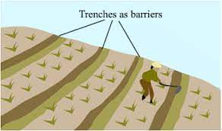
Rock dam
The dams also held to reduce the speed of water to conserve the soil.
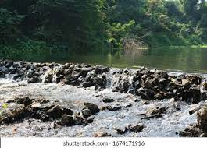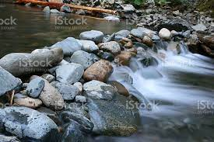

Terrace farming
In hilly areas farming done by making steps to reduce soil erosion is called terrace farming.
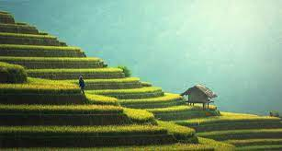

Contour ploughing
Ploughing parallel to the contours of a hill slope to form the natural barrier is called contour ploughing.
Shelter belts
In the coastal and dry regions, rows of trees are planted to reduce the speed of air, called as shelter belts.
Intercropping
Different crops are grown in alternate rows and are sown at different times to protect the soil from rain wash.

WATER
- Water is a very important renewable natural resource.
- Three-fourth of the earth surface is covered with water, but only 2.7 percent is freshwater, and only 1% of fresh water is available for human use.

WATER CYCLE
Water is cycling through the oceans, the air, the land and back again, through the processes of evaporation, precipitation and run-off.

This as you already know is referred to as the ‘water cycle’. So the amount of water is constant.
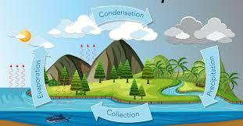

CAUSES OF SHORTAGE OF WATER
Ø Increasing population
Ø Rising demands for food and cash crops
Ø Increasing urbanisation and rising standards of living
Ø Water pollution is also the cause of water shortage.
It is due to discharge of untreated sewage, agricultural chemicals and industrial effluents in water bodies.
Water scarcity regions
There is scarcity of water in many regions of the world.
Most of Africa, West Asia, South Asia, parts of western USA, north-west Mexico, parts of South America and entire Australia are facing shortages of water.

WATER CONSERVATION
Water is very essential so we have to conserve it. We can take these steps to conserve the water.
Water conservation can be done by afforestation, adopting effective techniques for irrigation, drip or trickle irrigation and promoting rainwater harvesting.
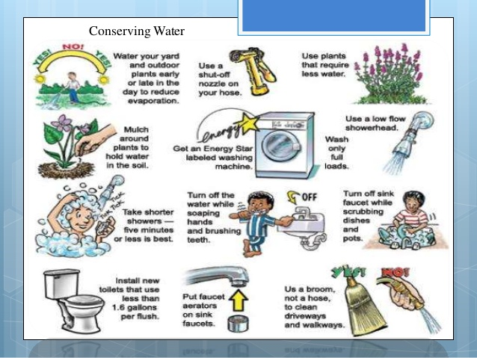

The canals should be properly lined to minimise losses by water seepage.
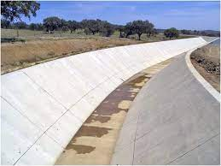
· Water pollution can be controlled by treating these effluents suitably before releasing them in water bodies.
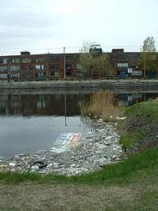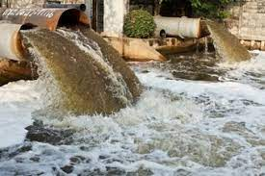

While brushing we should close the tap. We should not use shower while bathing. We should repair the leakage tapes.

NATURAL VEGETATION AND WILDLIFE:
Natural vegetation and wildlife exist only in the biosphere and they are interrelated and interdependent on each other for their survival. This system is called an ecosystem.

Importance of natural vegetation and wildlife
Natural vegetation and wildlife both are valuable resources.
Plants provide us with timber, give shelter to animals, produce oxygen we breathe, protect soils so essential for growing crops, act as shelter belts, storage of underground water, give us fruits, nuts, latex, turpentine oil, gum, medicinal plants and also the paper.
They are not only useful for us, but they also help in maintaining balance in nature.
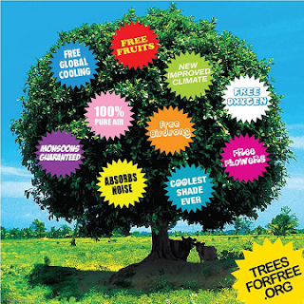
Wildlife provides us with milk, meat, hides and wool.

Insects like bees provide us with honey, help in pollination of flowers and have an important role to play as decomposers in the ecosystem.

The birds feed on insects and act as decomposers as well.

Vulture, due to its ability to feed on dead livestock is a scavenger and considered a vital cleanser.

Distribution Of Natural Vegetation
Major vegetations of the ecosystems are forests, grasslands, scrubs and Tundra.
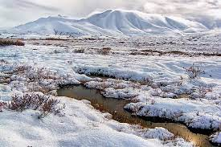
Tundra
Tundra is a type of region where tree growth is hindered by frigid temperatures

Forest
The forests are thus associated with areas having abundant water supply.
Forest can be classified into two types-
· Evergreen Forest

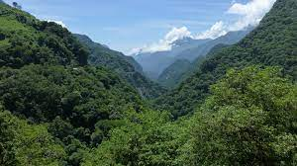
· Deciduous forest
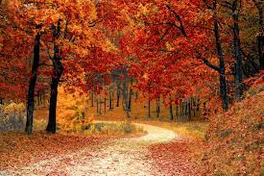

Evergreen Forest | Deciduous forest
These forests did not shed their leaves in a particular season. | These forests shed their leaves in a particular season.
They look evergreen almost every year. | They are called the monsoon forest.
Trees-Rosewood, Mahogany, Ebony etc. | Trees- Neem, Shisham, Peepal etc.
These can be classified according to areas- Tropical and Temperate | These can be classified according to areas- Tropical and Temperate
Grasslands- In the regions of moderate rainfall short trees and grassland are found.

Scrubs- In dry areas of low rainfall, thorny shrubs and scrubs grow. plants have deep roots and leaves have thorny and waxy surfaces to reduce loss of moisture.
Tundra- The vegetation of cold Polar Regions is known as tundra vegetation. It consists of mosses and lichens.
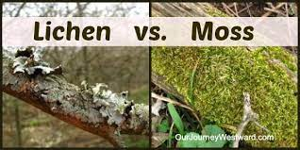
Causes of extinct of natural vegetation and wild life
Due to deforestation, soil erosion, constructional activities, forest fires, tsunami Tundra, landslides and poaching, many species of vegetation and wildlife have become extinct and many others are on the verge of extinction.
poaching
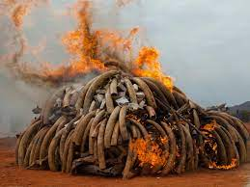
Ø Conservation Of Natural Vegetation And Wild Life
We can conserve natural vegetation and wildlife by these efforts-
By establishment of national parks, wildlife sanctuaries and biosphere reserves.
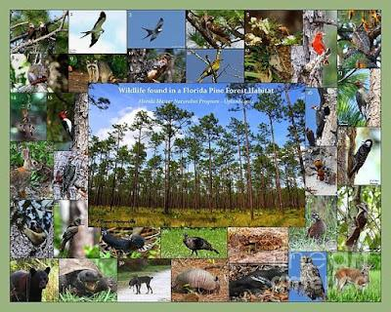
Awareness programmes like social forestry and Vanamahotsava should be encouraged at the regional and community level.
§ The government should make rules like the Killing of birds and animals illegal.
v Other Important Points
Ø Ninety per cent of the world population occupies only thirty per cent of land area.
Ø Landslides are simply defined as the mass movement of rock, debris or earth down a slope.
Ø Weathering The breaking up and decay of exposed rocks, by temperature changes, frost action, plants, animals and man.
Ø In India soils could be alluvial, black, red, laterite, desert and mountain soil.
Ø Amreli city in Saurashtra region with a population of 1.25 lakhs is completely dependent on purchasing water from the nearby talukas.
Ø Rain water harvesting is the process of collecting rainwater from roof tops and directing it to an appropriate location and storing it for future use.
Ø Vultures in the Indian subcontinent were dying due to diclofenac, a painkiller.
Ø National Park A natural area designated to protect the ecological integrity of one or more ecosystems for present and future generations.
Ø Biosphere reserves-The protected areas for the conservation of flora and fauna are known as biosphere reserves.
Ø CITES (the Convention on International Trade in Endangered Species of Wild Fauna and Flora) is an agreement to Ban the international trade to hide the animals.
Private Land: A part of land owned by a particular individual or group of individuals is called private land.
Community Land: A part of land not owned by anyone but meant for use by a large group of people living in a society, is called community land.
Deforestation: The action of cutting down trees is called deforestation.
Afforestation: The action of planting trees is called afforestation.

Parent Rock: The original rock from which soil has been formed is called its parent rock.
Scavenger: A bird or animal which feeds on dead livestock is called a scavenger.
Vanamahotsava: The social programme of planting trees, organised at community level is called vanamahotsava.
National Parks: A national park is a natural area supposed to be used to protect the ecological integrity of one or more ecosystems for the present and future generations.
Wildlife Sanctuaries: A wildlife sanctuary is similar to a national park, but it is supposed to protect a particular animal, in some cases, or wildlife in general, in other cases.

